Practical 1

Name- Anagha Rane

Roll No. - 02

Date of performance- 12/07/2021

1. AIM : Demonstrate basic data types in C and implement arithmetic expressions.

2. THEORY :

* Program always start with #include<stdio.h> ,where stdio stands for standard input output .
* The printf( ) and scanf( ) functions are used for input and output in C language. Both functions are inbuilt functions , defined in stdio.h (header file).
* Primitive data types in C are int , char , float , double .
* Primitive data types means they are predefined types of data, which are supported by the programming language. Int(signed/unsigned)(2,4 bytes): used to store integers. Char(signed/unsigned)(1 byte): used to store characters. Float, double(4,8bytes): used to store a decimal number.
* Format specifiers : %c - character format specifier , %d - integer format specifier , %f - floating point format specifier .
* Void main : C language is function oriented language. In this language we write programs through functions.
* Main is one of the functions of C . Its name is main because it is an important function , and must be used in C program, whether you are other functions or not.
* Void -which is written before main means that function main will not return a value.
* Void -which is written after main means that the function main will not send any argument.
* main( ) is the entry point of a program.
* When a file is executed , the start point is the main function. From main function the flow goes as per the programmers choice.
* getch( ); function is a member of conio.h library, hence we include this library at the top of our program. getch( ) stands for get character.
* clrscr( ); is a function used to clear the previous output from output window.
* Variables: variables are data that will keep on changing.
* Constant : it is a quantity which does not change.
* The allowable range for integer constants is -32768 to 32767.
* Keyword : keywords are predefined words. The programmer cannot change the meaning of keyword . so they cannot be used as name of variable, constants , array, function, structure, etc.
* Identifier : identifiers are user defined words.the meaning of identifier is not predefined. User can use identifier as a name of variable, array ,function, etc.
* Constant :constant means fixed value. The value of the constant cannot be change during the execution of the program.
* Operator : operator constructs an expression along with operands. Operators are used for -1. Perform mathematical calculations, 2.perform logical manipulation, 3.determine relationship between operands, 4.assign value of one operands or expression to another.
* String: A string is a sequence of characters that is enclosed between double quotation marks. FOR EX. "Hello".
* Special symbols : following are the special symbols used in C language-- #,+,-,*,/,%,&,|,',",: , ! ,? , (), {}, [], < >, =,\.

3.PROGRAM:

Que.(a). Write a C program to accept and print employee information like employee name,id,gender,contact no., salary.

Ans:

# include<stdio.h>

#include<conio.h>

int main()

{

char name[10];

char gender[1];

int contact;

int id;

float salary;

/*instruction for user*/

printf("enter employee name:");

scanf("%s", name);

printf("\nenter employee gender:");

scanf("%s",gender);

printf("\nenter employee contact number:");

scanf("%d",&contact);

printf("\nenter employee id:");

scanf("%d",&id);

printf("\nenter employee salary:");

scanf("%f",&salary);

/*print the result*/

printf("\nenter employee name:%s",name);

printf("\nenter employee gender:%s",gender);

printf("\nenter employee contact:%d",contact);

printf("\nenter employee id:%d",id);

printf("\nenter employee salary:%f",salary);

getch();

}

Que (b). write a C program to calculate:[accept length,breadth and radius from user].

[i] perimeter and area of rectangle

[ii]circumference and area of circle

Ans:

# include<stdio.h>

#include<conio.h>

#define PI 3.142

void main()

{

float l,b,r,p,a,c,A;

/*instruction for user*/

printf("\nenter length of rectangle=");

scanf("%f",&l);

printf("\nenter breadth of rectangle=");

scanf("%f",&b);

p=2*(l+b);

a=l*b;

/*print the result*/

printf("\nperimeter of rectangle=%f",p);

printf("\narea of rectangle=%f",a);

printf("\nenter radius of circle=");

scanf("%f",&r);

c=2*3.142*r;

A=3.142*r*r;

/*print the result*/

printf("\ncircumference of circle=%f",c);

printf("\narea of circle=%f",A);

getch();

}

Que(c): Input the distance between two cities(in km) and write a program to convert and print this distance in meters, feet, inches, and centimeters.

Ans:

# include<stdio.h>

#include<conio.h>

void main()

{

float km,m,f,in,cm;

/*instruction for user*/

printf("\nenter the distance in kilometers=");

scanf("%f",&km);

m=1000*km;

f=3280.84*km;

in=39370.1*km;

cm=100000*km;

/*print the result*/

printf("\ndistance in kilometres=%f",km);

printf("\ndistance in metres=%f",m);

printf("\ndistance in feet=%f",f);

printf("\ndistance in inches=%f",in);

printf("\ndistance in centimeters=%f",cm);

getch(0);

}

Que(d)Write a C program to find the displacement, s=ut+0.5at^2, where s:displacement;, u:initial velocity; , a:acceleration, t: time.

Ans:

# include<stdio.h>

#include<conio.h>

void main()

{

float u,t,a,s;

/*instruction for user*/

printf("\nenter initial velocity=");

scanf("%f",&u);

printf("\nenter time=");

scanf("%f",&t);

printf("\nenter acceleration=");

scanf("%f",&a);

s=u*t +0.5*a*t*t;

/*print the result*/

printf("\ndisplacement is %f",s);

getch(0);

}

4.OUTPUT:

Que(a) :

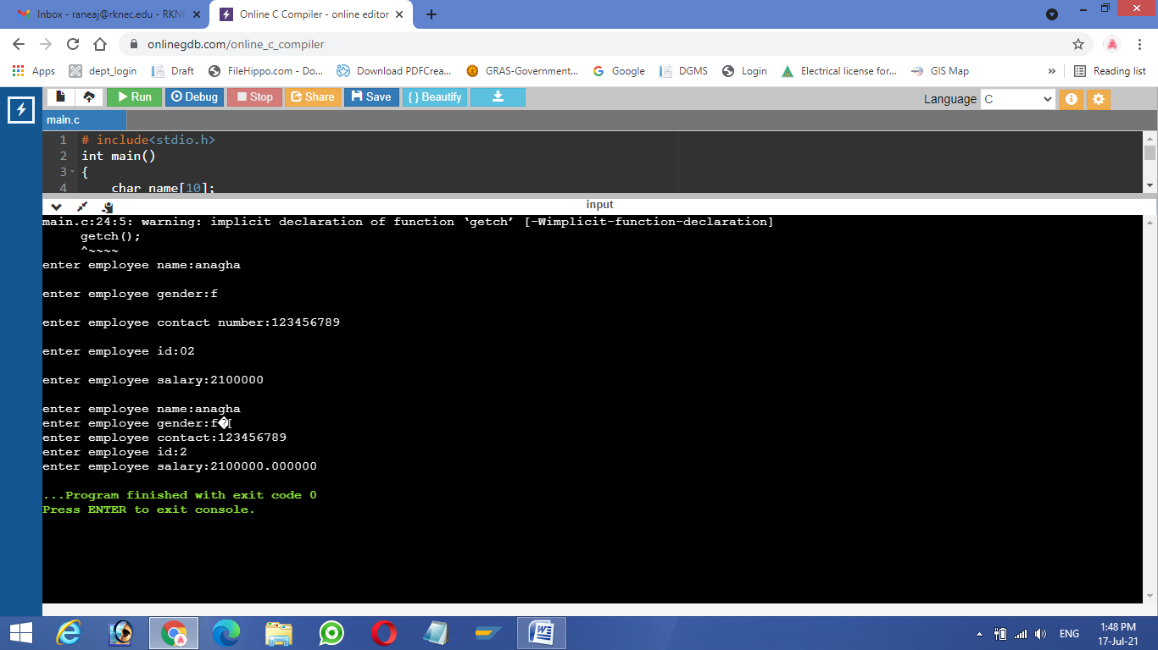

Que(b):

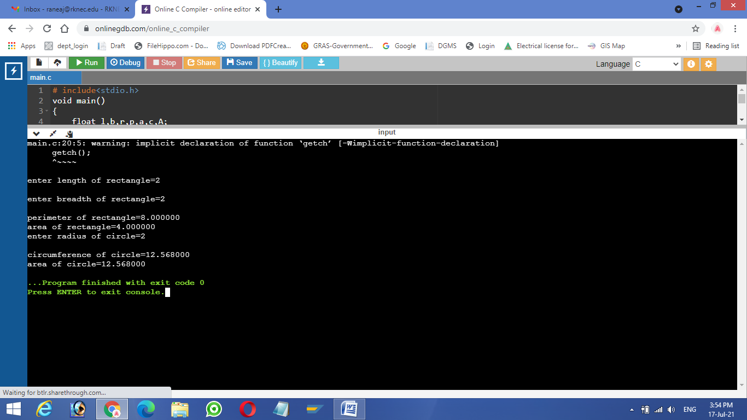

Que(c):

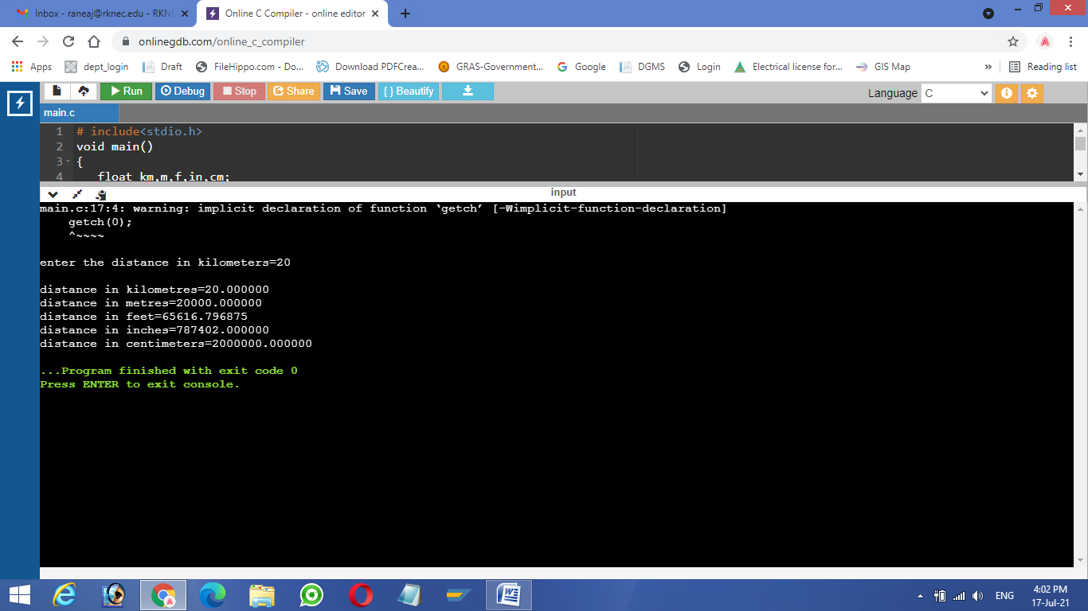

Que(d):

